The Roar of The More
Discover the Upgraded YOU That is Emergin
by Aimee Bernstein
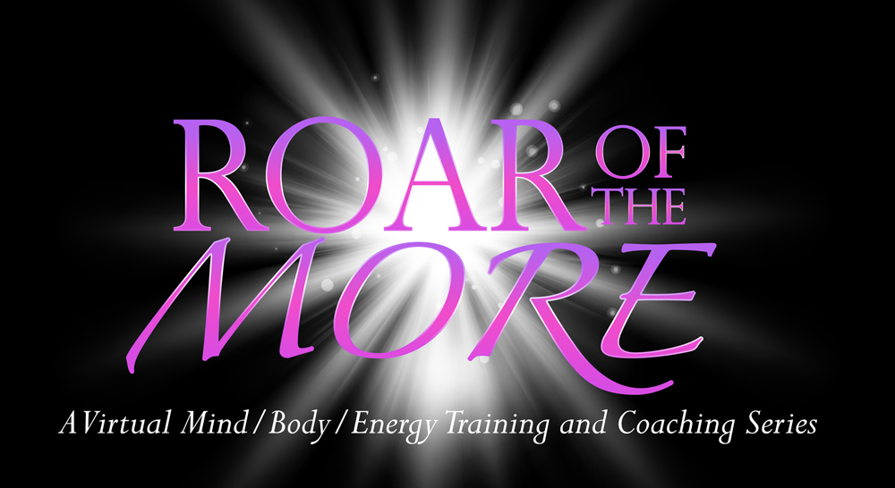
The theme of expansion shouts in my mind, my heart, my gut. It speaks of being more engaged and excited about life, living larger and deeper, and becoming the person I mam intended to be. It expresses itself in joy and it urges me to forge new connections and collaborations for goodness sake. I call this evolutionary impulse, The Roar of the MORE. Are you hearing it too? If so, get ready for a wild ride!
At first, The More comes upon us like the distant thunder announcing a storm. Although its center is not yet here, its power is so great that it compels us to take a clear look at our limiting beliefs, behaviors, and what we are attracting to us. And like a finely sharpened sword, The More cuts away parts of our lives that no longer serves us, whether we feel ready for that extraction or not.
"Do you mean I have to give up my belief that good, spiritual people don't have an abundance of money?" I asked myself.
"Do you mean it's not really about taking space from my girlfriend but about my being more internally spacious?" a dear friend said in amazement.
"Do you mean I can give up the clients I don't enjoy working with and use the time to paint?" a graphic artist questioned as a new door to her life stood ready to swing open.
YES, YES AND YES.
If you are like most people, your immediate reaction to The MORE is to tighten and clamp down on your stance in life. Prepared to hold on to what is known and which feels safe and comfortable, you may resist change, work harder, assert your will, or even call out to your band of angels for help. Yet clarity, control and peace evade you.
In fact, you may feel unsettled, out-of sorts, scared or depressed as you grapple to come to terms with what is occurring. Like stars that spiral their way into dark matter, we seem to be in a process of entropy. What we don't recognize at this point is that this dark hole is a portal leading us to finer dimensions of who we are. We are being expanded, elevated and called upon to show up in a new way. Yet, we only experience this upgrade when we surrender the fight and declare to the universe to do with us as it pleases. And when we do, to our amazement, standing right behind us are the sisters Hope and Faith to support us on our way.
I'd like to say that inner change will happen quickly but that is not the case. The MORE works its magic slowly. At first ideas and opportunities may arise, but to our chagrin they may quickly die out or be taken away. Other clues to our finer Self may be more like stepping stones than ultimate achievements. This may be frustrating or frightening the more the ego is involved.
Yet there are no mistakes. Life works. We reach our destiny in spite of ourselves.
As for me, I am being surprised by the shifts and changes in my business. In my most honest moments I realize that the work I loved before has become the work that no longer grows and excites me. Though it has been my cash cow, it is time to set it free in the pasture. Lately a sense of new contributions in service of the greater good inspires me. Although at times I wonder if I am delusional to think that big, I have begun to put pen to paper and sketch out a new intuited business plan and with it, the next best version of me. Faith and Hope-- are you still there?
There's no way around it. The Roar of the More is disruptive. It requires courage and wonder to surf its waves, which may at times feel like tsunamis. But if you let go of your ambition and ideas of who you are becoming; if you have the courage to trust your intuition and follow the clues life presents, the YOU that is emerging will begin to appear.
Riding through the turbulence and uncertainty I am learning that spiritual and material abundance are flip sides of the same coin. I am learning to thank the universe for making it so before it has actually manifested. But most importantly, I am learning that the me I think I am is just a whisper of who I truly am.
------Aimee Bernstein's The Roar of the MORE interactive coaching and training series guides people through a mind/body/energy journey to an upgraded level of well-being, performance, and consciousness. For more information on The Roar of the MORE go to https://openmindadventures.com/the-roar-of-the-more-brochure/ For a FREE 30 minute discovery call contact me at Aimee@Openmindadventures.com

